Frequently Asked Questions
Permanent Canal Closures & Pumps (PCCP)

What is the PCCP project?
The PCCP will be comprised of permanent gated storm surge barriers and brick façade pump stations at or near the lakefront of the 17th Street, Orleans Avenue and London Avenue outfall canals. The pumps will move rainwater out of the canals, around the gates, and into Lake Pontchartrain during a tropical weather event, and be equipped with a stand-alone emergency power supply capacity that allow it to operate independently of any publically provided utility.

When complete, the PCCP at 17th Street will consist of six 1,800 cubic feet per second (cfs) pumps and two 900 cfs pumps and have a total pumping capacity of 12,600 cfs; the PCCP at Orleans Avenue will consist of three 900 cfs pumps and have a total pumping capacity of 2,700 cfs; the PCCP at London Avenue will consist of four 1,800 cfs pumps and two 900 cfs pumps and have a total pumping capacity of 9,000 cfs. Fact Sheet

How was the PCCP project funded?
In June 2006, Congress authorized and provided funding for the Corps to design and construct Permanent Canal Closures and Pumps (PCCP) at or near the lakefront for the 17th Street, Orleans Avenue, and London outfall canals.

Where can I find environmental documents about the PCCP project? NOLA Environmental

When was the PCCP contract awarded?
On April 17, 2013, the U.S. Army Corps of Engineers, New Orleans District affirmed its decision to award the PCCP contract to the “PCCP Constructors, a Joint Venture” for design and construction of the Permanent Canal Closures and Pumps at the London Ave., Orleans Ave., and 17th Street outfall canals. Read News Release
Who is PCCP Constructors, a Joint Venture?
The PCCP Constructors, a Joint Venture (“PCCP Constructors” or “PCCP JV”) is comprised of Kiewit Louisiana South Co., Traylor Bros. Inc., and the M.R. Pittman group, LLC

What is a Design build concept?
Design-Build is a procurement procedure that links the designer and builder in one contract. This allows the project to be constructed quicker. For instance, while the designer is working on details of the upper portion of the structure the builder can work on the foundation allowing the project to proceed more rapidly to completion. The union of the designer and builder can also promote a more efficient construction schedule.

How is the contractor considering the visual impact to the community?
All practical efforts have been made to ensure that the design of these structures is as aesthetically pleasing as possible and the exterior of these structures conforms to other stations of their kind in the New Orleans area.

The Phase II Request for Proposal (RFP) Section 00105, Paragraph 2.2.5. included the following language: “Consideration of Impacts to the Community: All three PCCP facilities are in close proximity to residential areas. The Design-Builder shall minimize potential negative impacts to the surrounding communities during construction. In addition, facility design features shall include necessary considerations for aesthetics, noise, light pollution and similar issues to provide a community compatible facility. Visual impacts will also be reduced through enhanced landscaping.

When will construction be complete?
Major construction at all three pump stations is scheduled to be complete in 2017.

How will Interim Closure Structures (ICS) at 17th Street, Orleans Ave and London Ave function throughout the construction period? What will happen to the ICS following construction?
The Interim Closure Structures (ICS) at each of the outfall canals will remain in place and functional until the Permanent Canal Closures and Pumps are commissioned. During construction of the PCCP, the cofferdams will neither interfere with the flow of water through the Interim Closure Structures nor with the Sewerage & Water Board’s ability to pump. Following construction of the PCCP, the interim structures will be decommissioned and deconstructed through a separate contract.

How much did it cost to build the Interim Closure Structure (ICS)?
The three ICS facilities cost approximately $400 million to build. Construction of the facilities began in December 2005 and phase one was completed by July 1, 2006.

What type of construction impacts can I expect?

What to expect during construction… | Efforts to minimize impacts during construction
Elevated noise levels from pile driving, generators, etc.  Pile Driving Activities: 7 am-9 pm | Noise and vibration monitoring plan to ensure that construction adheres to city ordinances
Increased truck traffic (trucks will utilize approved haul routes) *plan reviewed by State of LA DOTD, City of New Orleans, Jefferson Parish | GPS tracking system to monitor contractor truck route
Temporary road closures | Coordinating with City of New Orleans Department of Public Works on temporary road closures
Extended work hours (up to 24 hours per day) | Construction signage indicating work ongoing / workers present; signage with construction impact hotline

How long will pile driving activities last?
All pile driving activities will be conducted between the hours of 7 a.m. – 9 p.m., Monday – Saturday. Generally speaking, the contractor will adhere to the abovementioned work schedule; however, there may be delays due to weather or other circumstances that cause the contractor to work seven days per week.

Will there be road closures during the construction period?
From time to time Lakeshore Drive and other streets will need to be closed on a temporary basis for the safety of the public and the workers on the project. Any such closures will be permitted by the local permitting agency and communicated to the public in advance of the closure.

What will the height of the new PCCP stations?
The floor of the pump station at 17th Street, Orleans Ave and London Avenue is at elevation 9 feet; the highest point of the building at the 17th Street and London Avenue PCCPs will be at elevation plus 52.9 feet. Thus, the actual height of the building at the 17th Street and London Avenue PCCP will be at 43.9 feet above the finished floor. At Orleans Avenue, the highest point of the building will be at elevation 49.9; thus, the actual height of the pump station will be 40.9 feet above the finished floor.

Where will material dredged from the canals be disposed?
All excavated material will be disposed of in accordance with applicable laws and regulations, including Louisiana Administrative Code (LAC) Title 33, Environmental Quality, Part VII, Solid Waste Regulations. If hazardous materials are encountered during excavation, these materials will be disposed of according to applicable environmental laws and regulations including LAC Title 33, Environmental Quality, Part V, Hazardous Waste and Hazardous Materials.

What are the haul routes for the PCCP project?
During construction of the PCCP, there will be impacts to residents. PCCP Constructors will continue to work closely with the Corps, the Coastal Protection and Restoration Authority Board of Louisiana, the Southeast Louisiana Flood Protection Authority-East, supporting levee districts, the City of New Orleans, and Jefferson Parish to minimize impacts and keep residents and businesses well informed of construction activities.

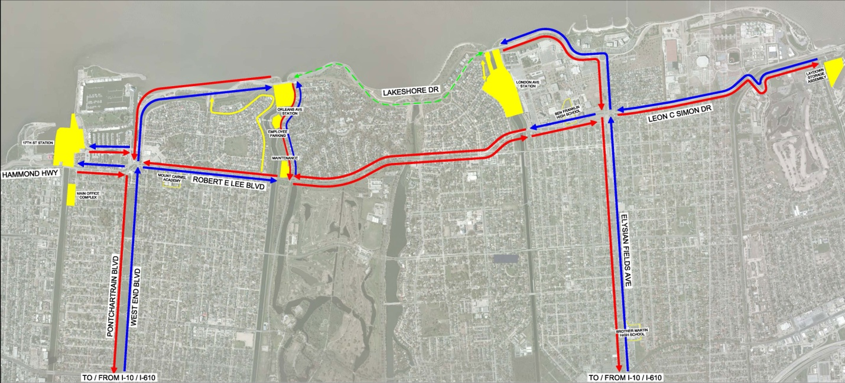
The map below identifies the approved construction haul routes. Blue indicates the primary truck route to the construction sites from Interstate-10, and red indicates the primary truck route from the construction sites to Interstate-10.Yellow indicates the secondary haul routes that will be used intermittently throughout construction and green indicates a limited haul throughout the construction period.

Who will be responsible for repairs to roadways following construction of the PCCP?
Negligent damage to roads is generally the responsibility of the party who negligently caused the damage. "Wear and tear" to a road is generally the responsibility of the non-federal agency that manages the road. If the contractor observes damage to the subject roadways caused by other parties, the contractor shall document the damage and immediately report it to the Government.
Who is going to clean mud and other debris from our streets, from our property, and will you wash my car?
Normal amounts of dust and dirt settling on your property and car from truck traffic is outside of the control of either the Corps or PCCP Constructors. PCCP Constructors is required to comply with state and local laws and regulations for dust and dirt control. PCCP Constructors is also required to clean areas of streets, as needed, to remove debris on the roadway which is from the contractors' trucks.

Who will operate and maintain the PCCP once the project is complete?
In accordance with authorizing legislation, the non-Federal Sponsor (Coastal Protection and Restoration Authority Board of Louisiana) is responsible for 100 percent of the Operations, Maintenance, Repair, Replacement and Rehabilitation (OMRR&R) costs of the PCCP project. The Coastal Protection and Restoration Authority Board of Louisiana has informed the Corps that it plans to enter into Cooperative Endeavor Agreements or sub-agreements, with other State or local entities for the performance of its OMRR&R obligations.

How can I stay informed about the PCCP project?
The Corps public affairs team and PCCP Constructors will be coordinating the information between the Corps/Contractor and the community. The Corps public affairs team and PCCPJV are proactively taking measures to educate the public about the PCCP project through public meetings, social media/ New Orleans District website, neighborhood associations / civic association visits, direct mail and neighborhood canvassing. Additional ways to stay informed about the project include:

- Website: http://www.mvn.usace.army.mil/Missions/HSDRRS/PCCP.aspx
- Follow on Facebook at: https://www.facebook.com/PermPumps
- Construction Impact Hotline: (877) 427-0345
- Follow on Twitter: @TeamNewOrleans
- AskTheCorps@usace.army.mil
- Flickr: http://www.flickr.com/photos/teamneworleans/sets/72157636355167283/
- Sign up for Weekly Construction Updates from PCCP JV: http://bit.ly/1b7ZbJ5

What is the plan for permanent lighting of the structures?
The lighting plan is currently in the design phase. Lighting instruments have been selected by PCCP JV and are currently undergoing photo-static testing to ensure that they will minimize ambient light to the surrounding area.

Will there be fencing around the structures?
There are two areas that require security fencing as part of the contract. One area is the East boundary of the London Ave. station adjacent to the UNO property. The second is on the west side of Orleans Ave. station running diagonally from the existing North / South levee to the East / West levee. PCCP Constructors is making every effort to place this fence behind the new “screening levee” and out of sight of the residents of the area. The design calls for a typical chain link style fence with security fencing on top. Fencing will not be required in any other areas due to the barrier provided by the new flood walls.

Who is the project’s owner?
The Coastal Protection and Restoration Authority Board of Louisiana is the owner of the project. The Corps has been granted a right-of-entry for construction purposes. Upon the construction completion of functional portions of the project, the New Orleans District Engineer will issue Notices of Construction Completion to the Coastal Protection & Restoration Authority Board of Louisiana.

Who is the project’s Contractor?
The PCCP project is being designed and built by PCCP Constructors, a Joint Venture (“PCCP Constructors” or “PCCP JV”). PCCP Constructors is comprised of three organizations in the industry. New Orleans based Kiewit Louisiana Co., Traylor Bros. Inc. based in Evanston Ill. and New Orleans-based M.R. Pittman Group.

Why are diesel powered generators being used as opposed to natural gas?
Several factors were considered in the decision to use diesel powered generators, primarily public safety. The Request for Proposal requires on site storage of a fuel supply that will allow the stations to operate for five continuous days without refueling.

The use of natural gas poses a far greater risk to the public should the storage system be compromised during a tropical event or other emergency. The second factor in this decision was reliability. Diesel powered engines provide the most reliable source of localized power generation. The third factor was efficiency. Natural gas powered engines are far less efficient than diesel powered ones, requiring much larger engines to supply the same amount of power. Diesel powered engines allow the structures to be built on a smaller footprint, requiring less space and visual impact than natural gas powered engines.

How often will the fuel tanks need to be refilled?
The fuel tanks should only need to be filled two to three times a year, depending on weather conditions.

Each of the pump station fuel farms is equipped with a Fuel Maintenance System (FMS). The FMS is a filtration system consisting of 10-micron filters and two fuel-water separators. It acts like a pool filter that, when scheduled through its own control panel, will turn on every week for a duration of a few hours.

First, each bulk fuel storage tank will be selected in sequence by the FMS control panels’ software. The FMS pump will turn on and fuel from the tank selected will run through the 10-micron filters and then through the fuel-water separators. These fuel-water separators have sensors that dump any water into an enclosed reservoir that is manually emptied by the pump station operators.

After several hours of filtering each tank, the system shuts down until scheduled to run again the next week. The implementation of the FMS alleviates the need for fuel trucks to enter the premises unless they are there to fill empty tanks. In this case, filling empty tanks only takes a day or two and should only need to be filled two to three times a year depending on weather conditions.

Were pre-construction surveys performed on the surrounding structures and roadways?
Pre-construction surveys (limited to above-ground structures) have been completed on the area trees and roadways. They have also been conducted on homes within 500 feet of the construction site. Post construction surveys will take place in the same locations. Residents were informed of these surveys by certified mail and neighborhood canvassing. All residents in these areas have been encouraged to participate.

What type of noise suppression policies are in place?
The PCCP Constructors’ Quality Control department has developed a noise and vibration monitoring plan that strives to ensure that construction adheres to City ordinances. The contractor will utilize Blast Mate Series III vibration monitors to measure and record vibration levels before and during construction. Extensive pre-construction surveys of structures close to the project have been taken and recorded.
Where is the construction workers’ parking being staged?
PCCP Constructors employee parking will be staged in public parking areas and /or within the permanent or temporary right-of-way (“ROW”) of the project. For the safety of the public and workers, PCCP Constructors requires that all employees of PCCP Constructors remain on project ROW during work hours except when traveling in company vehicles or equipment.
Who owns the property that contains the 17th Street construction hub offices on Bellaire Drive? What happen to that property once the construction project is complete?
There were 24 lots on Bellaire Drive purchased by the U.S. Army Corps of Engineers in the name of the Orleans Levee District (OLD) between December 2006 and November 2009. After construction of the PCCP project is completed in 2017 and the Interim Closure Structure (ICS) has been removed, the USACE will turn over ownership of the property to the OLD. At this time, no final plans for the site’s post-construction use have been determined.

